HPC Programs

#include <iostream>
#include <vector>
#include <omp.h>

using namespace std;

class Graph {
int V;
vector<vector<int>> adj;

public:
Graph(int V) {
this->V = V;
adj.resize(V);
}

void addEdge(int u, int v) {
adj[u].push_back(v);
adj[v].push_back(u);
}

void parallelBFS(int start) {
vector<bool> visited(V, false);
vector<int> frontier;

visited[start] = true;
frontier.push_back(start);

cout << "Parallel BFS from node " << start << ": ";

double start_time = omp_get_wtime();

while (!frontier.empty()) {
for (int u : frontier)
cout << u << " ";

vector<int> next_frontier;

#pragma omp parallel
{
vector<int> local_next;

#pragma omp for nowait schedule(dynamic)
for (int i = 0; i < (int)frontier.size(); i++) {
for (int v : adj[frontier[i]]) {
bool should_visit = false;
#pragma omp critical
{
if (!visited[v]) {
visited[v] = true;
should_visit = true;
}
}
if (should_visit)
local_next.push_back(v);
}
}

#pragma omp critical
{
next_frontier.insert(next_frontier.end(),
local_next.begin(),
local_next.end());
}
}

frontier = next_frontier;
}

double end_time = omp_get_wtime();

cout << "Time taken: " << (end_time - start_time) << " seconds\n";

cout << endl;
}

void parallelDFS(int start) {
vector<bool> visited(V, false);
vector<int> stack;

stack.push_back(start);

cout << "Parallel DFS from node " << start << ": ";

double start_time = omp_get_wtime();

while (!stack.empty()) {
int u = stack.back();
stack.pop_back();

if (visited[u]) continue;
visited[u] = true;
cout << u << " ";

vector<int> to_push;

#pragma omp parallel
{
vector<int> local_push;

#pragma omp for nowait schedule(dynamic)
for (int i = 0; i < (int)adj[u].size(); i++) {
if (!visited[adj[u][i]])
local_push.push_back(adj[u][i]);
}

#pragma omp critical
{
to_push.insert(to_push.end(),
local_push.begin(),
local_push.end());
}
}

for (int v : to_push)
stack.push_back(v);
}

double end_time = omp_get_wtime();

cout << "Time taken: " << (end_time - start_time) << " seconds\n";

cout << endl;
}
};

int main() {
Graph g(6);

g.addEdge(0, 1);
g.addEdge(0, 2);
g.addEdge(1, 3);
g.addEdge(1, 4);
g.addEdge(2, 5);

g.parallelBFS(0);
g.parallelDFS(0);

return 0;
}
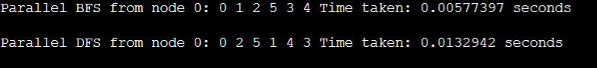

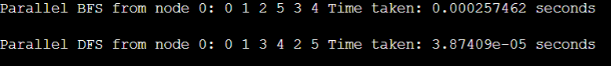

/*
* EXECUTION INSTRUCTIONS (Debian-based distributions):
*
* i) Install g++ with OpenMP support:
* sudo apt update
* sudo apt install g++
*
* ii) Compile:
* g++ -fopenmp Code-2.cpp -o Code-2
*
* iii) Execute:
* ./Code-2
* repository on KSKA Git: https://git.kska.io/sppu-be-comp-content/HighPerformanceComputing
**/

// BEGINNING OF CODE
#include <iostream>
#include <vector>
#include <cstdlib>
#include <omp.h>
#include <algorithm>

using namespace std;

void printArray(const vector<int>& arr) {
for (int num : arr)
cout << num << " ";
cout << endl;
}

void printArray10(const vector<int>& arr) {
for (int i = 0; i < min(10, (int)arr.size()); i++)
cout << arr[i] << " ";
cout << "... (truncated)" << endl;
}

// Bubble Sort

// Sequential bubble sort.
// Sorts the array using bubble sort by repeatedly swapping adjacent elements.
void sequentialBubbleSort(vector<int>& arr) {
int n = arr.size();
for (int i = 0; i < n - 1; i++) {
for (int j = 0; j < n - i - 1; j++) {
if (arr[j] > arr[j + 1])
swap(arr[j], arr[j + 1]);
}
}
}

// Parallel bubble sort using odd-even transposition.
// Standard bubble sort cannot be parallelized directly: thread on index j
// and thread on index j+1 would both touch arr[j+1] simultaneously (data race).
// Odd-even transposition alternates between two phases each pass:
// Phase 0 (even): compare pairs (0,1), (2,3), (4,5), ...
// Phase 1 (odd): compare pairs (1,2), (3,4), (5,6), ...
// Within each phase every pair is independent, so threads never share elements.
void parallelBubbleSort(vector<int>& arr) {
int n = arr.size();
for (int i = 0; i < n; i++) {
// i % 2 selects even phase (0) or odd phase (1).
// The starting index of the first pair in each phase matches i%2.
#pragma omp parallel for
for (int j = i % 2; j < n - 1; j += 2) {
if (arr[j] > arr[j + 1])
swap(arr[j], arr[j + 1]);
}
}
}

// Merge Sort

// Merges two sorted halves arr[left..mid] and arr[mid+1..right] in place.
void merge(vector<int>& arr, int left, int mid, int right) {
int n1 = mid - left + 1;
int n2 = right - mid;

vector<int> L(n1), R(n2);
for (int i = 0; i < n1; i++) L[i] = arr[left + i];
for (int i = 0; i < n2; i++) R[i] = arr[mid + 1 + i];

int i = 0, j = 0, k = left;
while (i < n1 && j < n2)
arr[k++] = (L[i] <= R[j]) ? L[i++] : R[j++];

while (i < n1) arr[k++] = L[i++];
while (j < n2) arr[k++] = R[j++];
}

void sequentialMergeSort(vector<int>& arr, int left, int right) {
if (left >= right) return;
int mid = left + (right - left) / 2;
sequentialMergeSort(arr, left, mid);
sequentialMergeSort(arr, mid + 1, right);
merge(arr, left, mid, right);
}

// Parallel merge sort using OpenMP tasks.
// "#pragma omp parallel sections" inside a recursive function would spawn a
// new thread team at every level of recursion, hundreds of thousands of teams
// for a large array, causing enormous overhead and likely a crash.
// Tasks are lighter: the runtime schedules them across an existing thread pool.
// The depth cutoff switches to sequential below a threshold to avoid spawning
// tasks so small that the overhead exceeds the work itself.
void parallelMergeSortHelper(vector<int>& arr, int left, int right) {
if (left >= right) return;

int mid = left + (right - left) / 2;

// Use threshold instead of depth (more reliable)
if (right - left < 1000) {
sequentialMergeSort(arr, left, right);
return;
}

#pragma omp task shared(arr)
parallelMergeSortHelper(arr, left, mid);

#pragma omp task shared(arr)
parallelMergeSortHelper(arr, mid + 1, right);

#pragma omp taskwait // ensure both halves are sorted

merge(arr, left, mid, right);
}

void parallelMergeSort(vector<int>& arr, int left, int right) {
#pragma omp parallel
{
#pragma omp single
parallelMergeSortHelper(arr, left, right);
}
}

// Main function

int main() {
int n = 10000; // Adjust this to specify the number of elements.
vector<int> arr(n);

for (int i = 0; i < n; i++)
arr[i] = rand() % 10000;

double start, end;
double time_seq_bubble, time_par_bubble;
double time_seq_merge, time_par_merge;

// --- Sequential Bubble Sort ---
vector<int> seqArr = arr;
start = omp_get_wtime();
sequentialBubbleSort(seqArr);
end = omp_get_wtime();
time_seq_bubble = end - start;
cout << "Sequential Bubble Sort time: " << time_seq_bubble << " seconds" << endl;

// --- Parallel Bubble Sort ---
vector<int> parArr = arr;
start = omp_get_wtime();
omp_set_num_threads(2);
parallelBubbleSort(parArr);
end = omp_get_wtime();
time_par_bubble = end - start;
cout << "Parallel Bubble Sort time: " << time_par_bubble << " seconds" << endl;

cout << "Bubble Sort Speedup (Sequential / Parallel) = " << (time_seq_bubble / time_par_bubble) << "x" << endl;

cout << "\nParallel Bubble Sort (first 10 elements): ";
printArray10(parArr);

if (is_sorted(parArr.begin(), parArr.end()))
cout << "Array is sorted correctly\n";

cout << "Parallel Bubble Sort time: " << time_par_bubble << " seconds" << endl;

// --- Sequential Merge Sort ---
seqArr = arr;
start = omp_get_wtime();
sequentialMergeSort(seqArr, 0, n - 1);
end = omp_get_wtime();
time_seq_merge = end - start;
cout << "\nSequential Merge Sort time: " << time_seq_merge << " seconds" << endl;

// --- Parallel Merge Sort ---
parArr = arr;
start = omp_get_wtime();
omp_set_num_threads(8);
parallelMergeSort(parArr, 0, n - 1);
end = omp_get_wtime();
time_par_merge = end - start;
cout << "Parallel Merge Sort time: " << time_par_merge << " seconds" << endl;

cout << "Merge Sort Speedup (Sequential / Parallel) = " << (time_seq_merge / time_par_merge) << "x" << endl;

cout << "\nParallel Merge Sort (first 10 elements): ";
printArray10(parArr);

if (is_sorted(parArr.begin(), parArr.end()))
cout << "Array is sorted correctly\n";

cout << "Parallel Merge Sort time: " << time_par_merge << " seconds" << endl;

return 0;
}

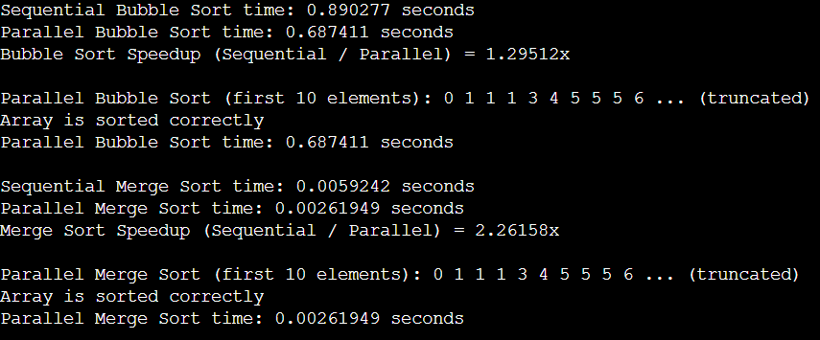

#include <iostream>
#include <vector>
#include <omp.h>
#include <cstdlib>

using namespace std;

int main(){

int n = 1000000;
vector<int> nums(n);
for(int i=0;i<n;i++){
nums[i] = rand() % 10000;
}
cout<<"Input: "<<n<<endl;

long long sums,sump;
int mins,maxs,minp,maxp;
double avgs,avgp;
double start,end,times,timep;

mins, maxs = nums[0];
sums = 0;
start = omp_get_wtime();
for(int i=0;i<n;i++){
if(nums[i]<mins)
mins = nums[i];
if(nums[i]>maxs)
maxs = nums[i];
sums+=nums[i];
}
end = omp_get_wtime();
avgs = (double) sums/n;
times = end-start;
cout<<"Time sequential: "<<times<<endl;

minp, maxp = nums[0];
sump = 0;
start = omp_get_wtime();
#pragma omp parallel for reduction(min: minp) reduction(max: maxp) reduction(+:sump)
for(int i=0;i<n;i++){
if(nums[i]<minp)
minp = nums[i];
if(nums[i]>maxp)
maxp = nums[i];
sump+=nums[i];
}
end = omp_get_wtime();
avgp = (double) sump/n;
timep = end-start;
cout<<"Time parallel: "<<timep<<endl;

// --- Output ---
cout << "--- Sequential Computation ---" << endl;
cout << "Minimum : " << mins << endl;
cout << "Maximum : " << maxs << endl;
cout << "Sum : " << sums << endl;
cout << "Average : " << avgs << endl;
cout << "Time : " << times << " seconds" << endl;

cout << "\n--- Parallel Computation ---" << endl;
cout << "Minimum : " << minp << endl;
cout << "Maximum : " << maxp << endl;
cout << "Sum : " << sump << endl;
cout << "Average : " << avgp << endl;
cout << "Time : " << timep << " seconds" << endl;

cout << "\nSpeedup (Sequential / Parallel) = " << (times / timep) << "x" << endl;

return 0;
}
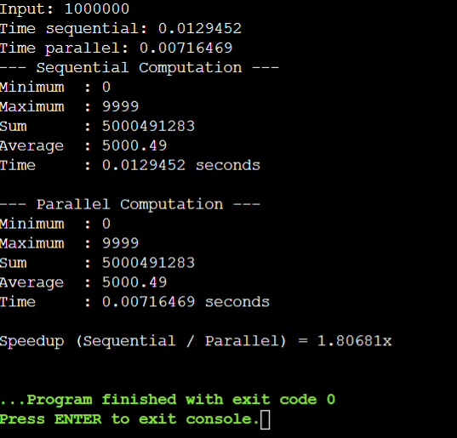
===============================================================
Functions

#include <iostream>
#include <vector>
#include <omp.h>
#include <cstdlib>

using namespace std;

// Function to generate random numbers
vector<int> generateData(int n) {
vector<int> nums(n);
for (int i = 0; i < n; i++)
nums[i] = rand() % 10000;
return nums;
}

// Sequential computation
void sequentialCompute(const vector<int>& nums, int &min_val, int &max_val, long long &sum, double &avg, double &time_taken) {
int n = nums.size();
min_val = max_val = nums[0];
sum = 0;

double start = omp_get_wtime();

for (int i = 0; i < n; i++) {
if (nums[i] < min_val) min_val = nums[i];
if (nums[i] > max_val) max_val = nums[i];
sum += nums[i];
}

double end = omp_get_wtime();
time_taken = end - start;

avg = (double)sum / n;
}

// Parallel computation
void parallelCompute(const vector<int>& nums, int &min_val, int &max_val, long long &sum, double &avg, double &time_taken) {
int n = nums.size();
min_val = max_val = nums[0];
sum = 0;

double start = omp_get_wtime();

#pragma omp parallel for reduction(min: min_val) reduction(max: max_val) reduction(+: sum)
for (int i = 0; i < n; i++) {
if (nums[i] < min_val) min_val = nums[i];
if (nums[i] > max_val) max_val = nums[i];
sum += nums[i];
}

double end = omp_get_wtime();
time_taken = end - start;

avg = (double)sum / n;
}

// Function to print results
void printResults(string title, int min_val, int max_val, long long sum, double avg, double time_taken) {
cout << "--- " << title << " ---" << endl;
cout << "Minimum : " << min_val << endl;
cout << "Maximum : " << max_val << endl;
cout << "Sum : " << sum << endl;
cout << "Average : " << avg << endl;
cout << "Time : " << time_taken << " seconds" << endl;
}

int main() {
int n = 1000000;

// Generate data
vector<int> nums = generateData(n);

cout << "Input: " << n << " random integers in the range [0, 9999].\n" << endl;

// Variables
int min_seq, max_seq, min_par, max_par;
long long sum_seq, sum_par;
double avg_seq, avg_par;
double time_seq, time_par;

// Sequential
sequentialCompute(nums, min_seq, max_seq, sum_seq, avg_seq, time_seq);

// Parallel
parallelCompute(nums, min_par, max_par, sum_par, avg_par, time_par);

// Output
printResults("Sequential Computation", min_seq, max_seq, sum_seq, avg_seq, time_seq);
cout << endl;
printResults("Parallel Computation", min_par, max_par, sum_par, avg_par, time_par);

cout << "\nSpeedup (Sequential / Parallel) = " << (time_seq / time_par) << "x" << endl;

return 0;
}

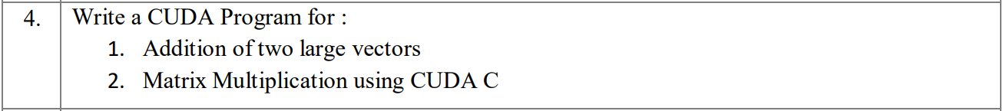

Practical-4 (Vector Addition and Matrix Multiplication)
Problem Statement: Write a CUDA Program for:
- Addition of two large vectors
- Matrix Multiplication using CUDA C

Pre-requisities
- Open Google Colab
- Create a new Jupyter Notebook

Steps

1. After creating a new Jupyter notebook, click on "Runtime" in the navbar:
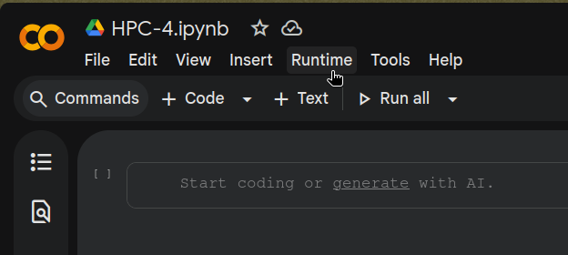

2. Then, choose "Change runtime type":
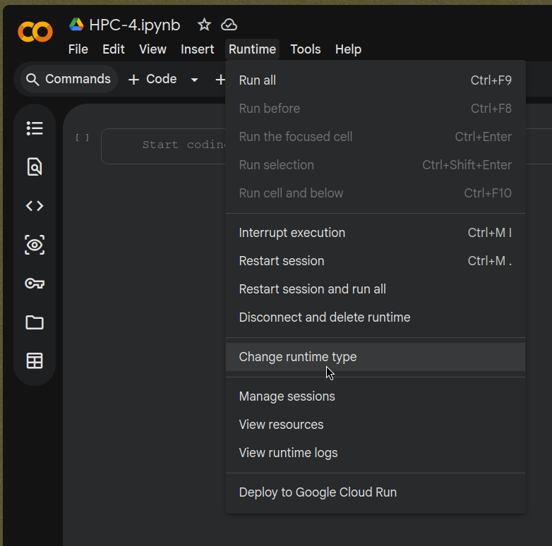

3. Select "T4 GPU", and save:
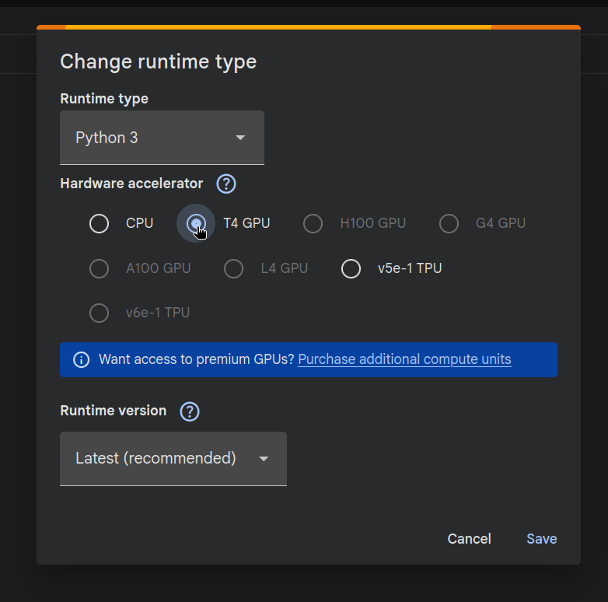

4. Check if nvcc is installed:
!nvcc --version

5. Install nvcc4jupyter:
!pip install nvcc4jupyter
# Or if the above command fails, comment the above line and run
# !pip install git+https://git.kska.io/notkshitij/nvcc.git

6. Load it:
%load_ext nvcc4jupyter

7. Paste the below code in a new code block:
%%writefile cuda_program.cu
#include <iostream>
#include <cuda.h>

using namespace std;

#define BLOCK_SIZE 2

// Vector Addition Kernel
// Each thread computes a single element of C = A + B.
__global__ void vectorAdd(int *A, int *B, int *C, int N) {
int i = blockIdx.x * blockDim.x + threadIdx.x;
// Guard against threads beyond the vector size (when N is not a multiple
// of the block size, some threads in the last block are out of range).
if (i < N)
C[i] = A[i] + B[i];
}

// Matrix Multiplication Kernel
// Each thread computes a single element of C = A * B.
// Thread (row, col) sums the dot product of row `row` of A with column `col` of B.
__global__ void matrixMul(float *A, float *B, float *C, int N) {
int row = blockIdx.y * blockDim.y + threadIdx.y;
int col = blockIdx.x * blockDim.x + threadIdx.x;

float sum = 0.0f;
for (int n = 0; n < N; ++n)
sum += A[row * N + n] * B[n * N + col];

C[row * N + col] = sum;
}

// Vector Addition
void runVectorAddition() {
int N;
cout << "\n=== Vector Addition ===" << endl;
cout << "Enter vector size: ";
cin >> N;

int size = N * sizeof(int);

// Host allocation and initialisation
int *hA = new int[N];
int *hB = new int[N];
int *hC = new int[N];

for (int i = 0; i < N; i++) {
hA[i] = i;
hB[i] = i * 2;
}

cout << "\nVector A: ";
for (int i = 0; i < N; i++) cout << hA[i] << " ";
cout << "\nVector B: ";
for (int i = 0; i < N; i++) cout << hB[i] << " ";
cout << endl;

// Device allocation and transfer
int *dA, *dB, *dC;
cudaMalloc(&dA, size);
cudaMalloc(&dB, size);
cudaMalloc(&dC, size);

cudaMemcpy(dA, hA, size, cudaMemcpyHostToDevice);
cudaMemcpy(dB, hB, size, cudaMemcpyHostToDevice);

// Launch with enough blocks to cover all N elements.
// (N + BLOCK_SIZE - 1) / BLOCK_SIZE rounds up so we don't miss the tail.
int numBlocks = (N + BLOCK_SIZE - 1) / BLOCK_SIZE;
vectorAdd<<<numBlocks, BLOCK_SIZE>>>(dA, dB, dC, N);

cudaMemcpy(hC, dC, size, cudaMemcpyDeviceToHost);

cout << "Result A + B: ";
for (int i = 0; i < N; i++) cout << hC[i] << " ";
cout << endl;

delete[] hA;
delete[] hB;
delete[] hC;
cudaFree(dA);
cudaFree(dB);
cudaFree(dC);
}

// Matrix Multiplication
void runMatrixMultiplication() {
int K, N;
cout << "\n=== Matrix Multiplication ===" << endl;
cout << "Enter K (matrix will be N x N where N = K * " << BLOCK_SIZE << "): ";
cin >> K;
N = K * BLOCK_SIZE;

cout << "Matrix size: " << N << " x " << N << endl;
int size = N * N * sizeof(float);

// Host allocation and initialisation
float *hA = new float[N * N];
float *hB = new float[N * N];
float *hC = new float[N * N];

for (int j = 0; j < N; j++) {
for (int i = 0; i < N; i++) {
hA[j * N + i] = 2;
hB[j * N + i] = 4;
}
}

cout << "\nMatrix A:\n";
for (int row = 0; row < N; row++) {
for (int col = 0; col < N; col++)
cout << hA[row * N + col] << " ";
cout << endl;
}

cout << "\nMatrix B:\n";
for (int row = 0; row < N; row++) {
for (int col = 0; col < N; col++)
cout << hB[row * N + col] << " ";
cout << endl;
}

// Device allocation and transfer
float *dA, *dB, *dC;
cudaMalloc(&dA, size);
cudaMalloc(&dB, size);
cudaMalloc(&dC, size);

cudaMemcpy(dA, hA, size, cudaMemcpyHostToDevice);
cudaMemcpy(dB, hB, size, cudaMemcpyHostToDevice);

// threadBlock: BLOCK_SIZE x BLOCK_SIZE threads per block.
// grid: K x K blocks, so total threads = N x N (one per output element).
dim3 threadBlock(BLOCK_SIZE, BLOCK_SIZE);
dim3 grid(K, K);
matrixMul<<<grid, threadBlock>>>(dA, dB, dC, N);

cudaMemcpy(hC, dC, size, cudaMemcpyDeviceToHost);

cout << "\nResult C = A * B:\n";
for (int row = 0; row < N; row++) {
for (int col = 0; col < N; col++)
cout << hC[row * N + col] << " ";
cout << endl;
}

delete[] hA;
delete[] hB;
delete[] hC;
cudaFree(dA);
cudaFree(dB);
cudaFree(dC);
}

int main() {
runVectorAddition();
runMatrixMultiplication();

cout << "\nFinished." << endl;
return 0;
}

8. Compile and run:
!nvcc cuda_program.cu -o cuda_program && ./cuda_program

Sample output
=== Vector Addition ===
Enter vector size: 2

Vector A: 0 1
Vector B: 0 2
Result A + B: 0 3

=== Matrix Multiplication ===
Enter K (matrix will be N x N where N = K * 2): 3
Matrix size: 6 x 6

Matrix A:
2 2 2 2 2 2
2 2 2 2 2 2
2 2 2 2 2 2
2 2 2 2 2 2
2 2 2 2 2 2
2 2 2 2 2 2

Matrix B:
4 4 4 4 4 4
4 4 4 4 4 4
4 4 4 4 4 4
4 4 4 4 4 4
4 4 4 4 4 4
4 4 4 4 4 4

Result C = A * B:
48 48 48 48 48 48
48 48 48 48 48 48
48 48 48 48 48 48
48 48 48 48 48 48
48 48 48 48 48 48
48 48 48 48 48 48

Finished.

